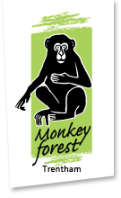
Monkey Maths
Answers Sheet

- 2 + 3 = 5
- 4 – 1 = 3
- 5 + 3 = 8
- 6 – 4 = 2
- 3 + 2 – 1 = 4
- 7 – 3 = 4
- 2 + 10 = 12
- 6 – 1 + 4 = 8
- 10 + 3 = 23 species of macaques
- 100 + 40 = 140 Barbary macaques live at Trentham Monkey Forest

