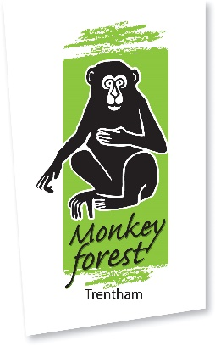
Animals of Morocco
Answer Sheet

Answers:
DO live in North Africa: Barbary macaque, Golden wolf, Waldropp Ibis, Fenneck Fox, African Wildcat.
DO NOT live in North Africa: Lar Gibbon (Asia), Maned Wolf (South America), Cassowary (Australia), Tibetan Fox (Tibet, North Asia), Tiger (Asia and northern Europe).

