Ice Cream Van | 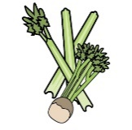 | 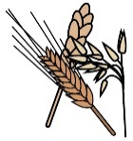 | 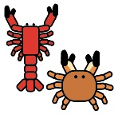 | 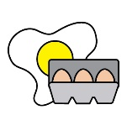 | 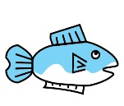 | 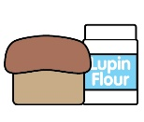 | 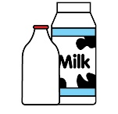 |  | 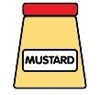 | 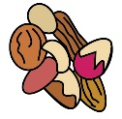 | 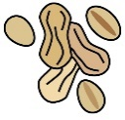 | 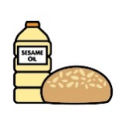 |  | 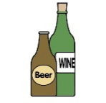
Meats | Celery | Cereals containing gluten* | Crustaceans | Eggs | Fish | Lupin | Milk | Mollusc | Mustard | Nuts† | Peanuts | Sesame seeds | Soya | Sulphur Dioxide
Banana  Vegetarian friendly  Not Vegan | x | x | x | x | x | x | ✓ | x | x | May Contain | May Contain | x | x | x
Chocolate  Vegetarian friendly  Not Vegan | x | x | x | x | x | x | ✓ | x | x | May Contain | May Contain | x | x | x
Raspberry Ripple  Vegetarian friendly  Not Vegan | x | x | x | x | x | x | ✓ | x | x | May Contain | May Contain | x | x | x
Salted Caramel  Vegetarian friendly  Not Vegan | x | x | x | x | x | x | ✓ | x | x | May Contain | May Contain | x | x | x
Strawberries & Cream  Vegetarian friendly  Not Vegan | x | x | x | x | x | x | ✓ | x | x | May Contain | May Contain | x | x | x
Vanilla  Vegetarian friendly  Not Vegan | x | x | x | x | x | x | ✓ | x | x | May Contain | May Contain | x | x | x
Teddy Cone  Vegetarian friendly  Vegan friendly | x | ✓ (Wheat) | x | x | x | x | x | x | x | x | x | x | ✓ | x
Waffle Cone  Vegetarian friendly  Not Vegan | x | ✓ (Wheat) | x | x | x | x | ✓ | x | x | x | x | x | ✓ | x

